# Ex No 9

Implement clustering techniques – Hierarchical and K-Means

# AIM:

To Implement clustering techniques – Hierarchical and K-Means using R.

# PROCEDURE:

* Collect and load the dataset from sources like CSV files or databases.
* Clean and preprocess the data, including handling missing values and scaling features.
* Determine the number of clusters (K) for K-Means, or decide on the stopping criterion for Hierarchical Clustering.
* Choose the appropriate clustering algorithm: K-Means for partitioning, Hierarchical for nested clustering.
* Apply the K-Means algorithm using fit_predict to assign data points to clusters.
* Apply the Hierarchical Clustering algorithm using Agglomerative Clustering for hierarchical clusters.
* Visualize the clusters with scatter plots for K-Means, and dendrograms for Hierarchical Clustering.
* Evaluate clustering performance using metrics like silhouette score or inertia (for K- Means).
* Fine-tune the clustering by adjusting the number of clusters or linkage criteria.
* Interpret the results to understand the structure and relationships within the data.

# CODE:

**Hierarchical Clustering.R:**

# Load the iris dataset data(iris)

# Use only the numeric columns for clustering (exclude the Species column) iris_data <- iris[, -5]

# Standardize the data iris_scaled <- scale(iris_data)

# Compute the distance matrix

distance_matrix <- dist(iris_scaled, method = "euclidean")

# Perform hierarchical clustering using the "complete" linkage method hc_complete <- hclust(distance_matrix, method = "complete")

# Plot the dendrogram

plot(hc_complete, main = "Hierarchical Clustering Dendrogram", xlab = "", sub = "", cex = 0.6)

# Cut the tree to form 3 clusters clusters <- cutree(hc_complete, k = 3) # Print the cluster memberships print(clusters)

# Add the clusters to the original dataset iris$Cluster <- as.factor(clusters)

# Display the first few rows of the updated dataset head(iris)

# K-Means Clustering.R:

# Load the iris dataset data(iris)

# Use only the numeric columns for clustering (exclude the Species column) iris_data <- iris[, -5]

# Standardize the data iris_scaled <- scale(iris_data) # Set the number of clusters

set.seed(123) # For reproducibility k <- 3 # Number of clusters

# Perform K-Means clustering

kmeans_result <- kmeans(iris_scaled, centers = k, nstart = 25)

# Print the K-Means result print(kmeans_result)

# Print the cluster centers print(kmeans_result$centers)

# Add the cluster assignments to the original dataset iris$Cluster <- as.factor(kmeans_result$cluster)

# Display the first few rows of the updated dataset head(iris)

# Plot the clusters library(ggplot2)

ggplot(iris, aes(x = Sepal.Length, y = Sepal.Width, color = Cluster)) + geom_point(size = 3) +

labs(title = "K-Means Clustering of Iris Dataset", x = "Sepal Length", y = "Sepal Width")

# OUTPUT:

**Hierarchical Clustering:**

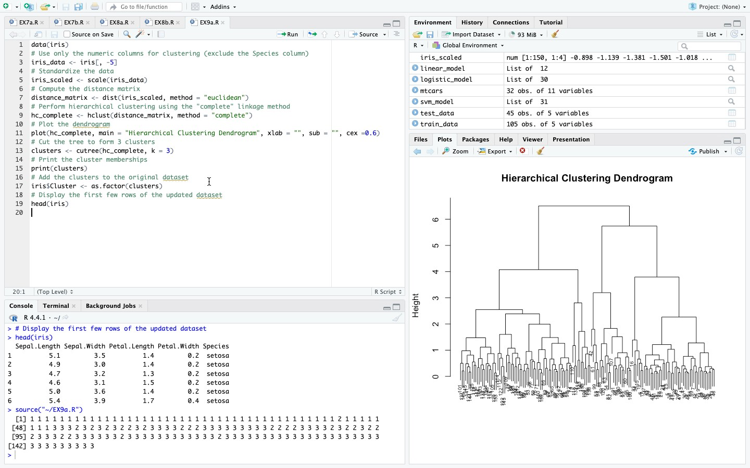

# K-Means Clustering:

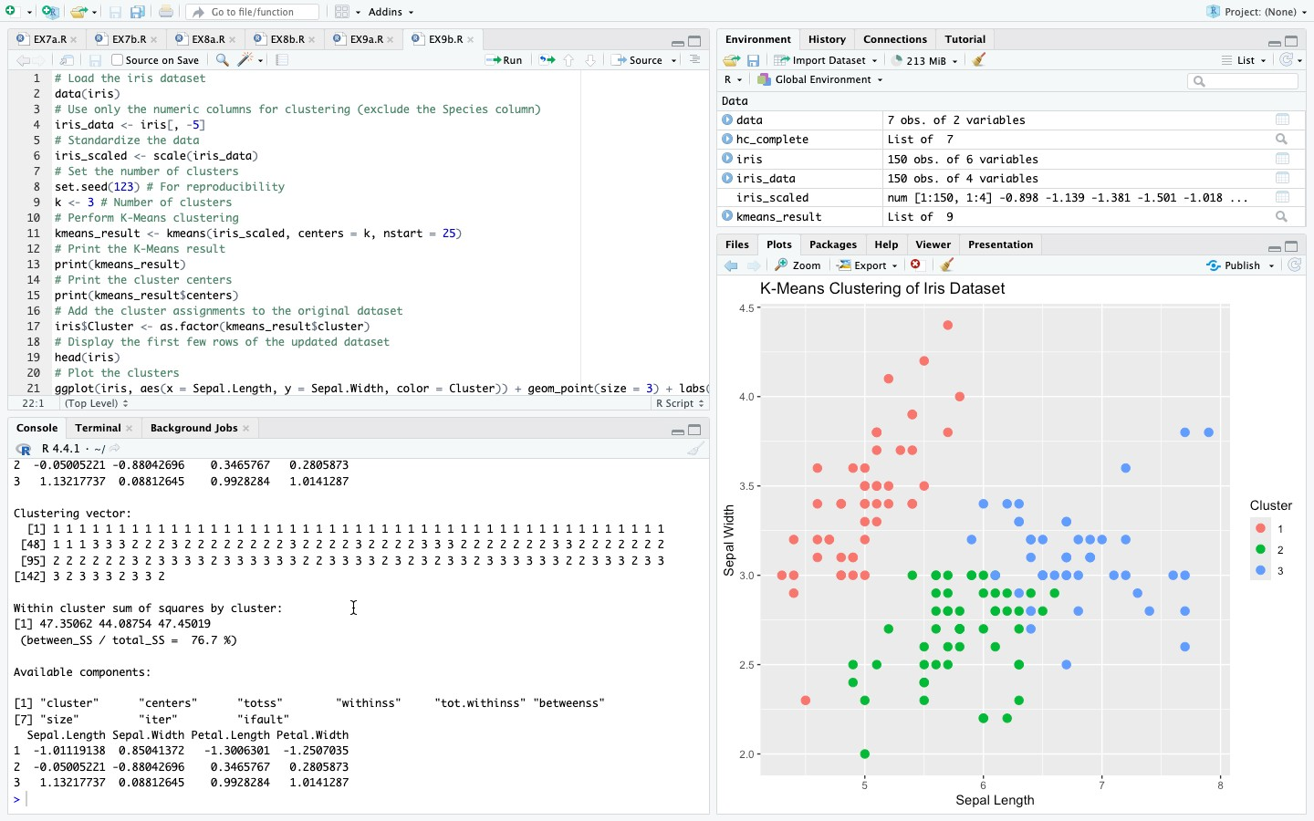

**RESULT:**

Thus, to implement clustering techniques – Hierarchical and K-Means using R has been successfully executed.